Action Planner

An Action Planner:
- is a tool to map the process of student action
- encourages students to plan their learning and can be utilized as part of inquiry learning
Context:  Taking Action | Concepts:  - Responsibility for Action | NZC Level:  1-8 | Timeframe:  2 weeks up to 2 terms
EfS in the NZC

- Vision – ‘actively involved’ p.8
- Values – ‘make ethical decisions and act on them’ p.10
- Effective Pedagogy – ‘encouraging reflective thought and action’ p.34
- Taking action is a key component of Education for Sustainability and supports the development of all the key competencies as students develop their action competence
The Learning Context

This is a process for supporting students to take informed action on issues of concern to them. It should:
- prompt thinking on what to do and why
- focus action on the sustainability to be addressed
- support students in planning and taking their action.
Concepts for EfS
Teachers need to connect students’ learning to concepts in EfS and school based broad understandings for learning so that students can make sense of their knowledge, about their experiences of and attitudes towards sustainability.

Throughout the unit of work students will develop an understanding of the concept of
Responsibility for Action by experiencing taking action on an issue of concern to them.
Student learning outcomes

- to collaboratively identify a sustainability issue
- to collaboratively create a vision that will address the issue
- to plan an action that will address the identified sustainability issue
- to make decisions about an action(s)
- to work collaboratively to carry out an action
- to reflect on actions taken.

Learning sequence  Action Planning should be carried out with a whole class until students become familiar with the process. Once familiar, students can complete Action Planners in small groups or individually.  Generic action planning process  - Raise the issue with the students.  - Identify the issue with students.  - Explore possibilities to clarify the vision with students i.e. what is it that we want to achieve?  - Plan the action. Consider what exactly needs to be done to achieve the vision. This could include several smaller projects within the larger project that either the whole class is involved with over time, or small groups within the class facilitate. Check that the action addresses the issue.  - Consider the skills required to carry out the action and where more information can be found.  - Consider how people will think and feel about the planned action and how you will find this out.  - Make some decisions: what could influence your decision making? List the options and criteria in a decision making matrix to choose the action. Criteria should include:  - ensuring the action addresses the issue  - resources required  - time and learning.  Add your own criteria as required.  - Carry out the action.  - Reflect on change. Some questions may include:  - How can we make people more aware of the issue and our action(s)?  - Did our actions meet our vision?  - Did our actions impact on the issue we identified?  - What do we need to do next? | Teaching and learning  Learning inquiry  What happened during the learning?  How did my students respond?  How will this learning contribute to a sustainable future?  How can this learning make a difference?  What is next?
Edible Garden Example:  - Visit community gardens  - Walk around the school grounds  - Have a visitor to the class  - Participate in a competition, for example ‘Spud in Bucket’ – see www.tahuriwhenua.org.nz etc.  - Examples of Issues:  - Lack of biodiversity in our school  - Some children coming to school without lunch  - Learning where our food comes from.  - Examples of Visions:  - To create a class edible garden  - To create container gardens to attract butterflies  - To create five small group herb gardens  - To create a whole school usable garden.  - Examples of Actions (to achieve the vision):  - Surveying the school community: Who has gardens at home? What edible plants do we want to be able to eat at school?  - Designing the garden: calculating the amount of materials required; exploring options for garden placement; investigating which plants can be planted; consulting others in the school and community for advice.  - Examples of skills:  - Measuring areas and volumes  - Building gardens  - Physical gardening skills (digging, carrying, using a wheelbarrow, weeding)  - Identifying plants  - Interviewing gardeners  - Reading plant catalogues  - Examples of information sources:  - Local families with gardens  - Experienced gardeners  - Community gardens  - Internet  - Books  - Examples of people to consider:  - School caretaker  - Other students and teachers  - Principal  - BoT, PTA, community members  - Examples of criteria that could influence our decision:  - Cost  - Reusable resources/second hand  - Time allowance  - Learning  - Meets the issue identified | Teaching and learning  Learning inquiry  What happened during the learning?  How did my students respond?  How will this learning contribute to a sustainable future?  How can this learning make a difference?  What is next?
Action Planning process (to complete with students)
Example 1
Note: this process is not linear and these steps should be used as a guide to develop your action plan

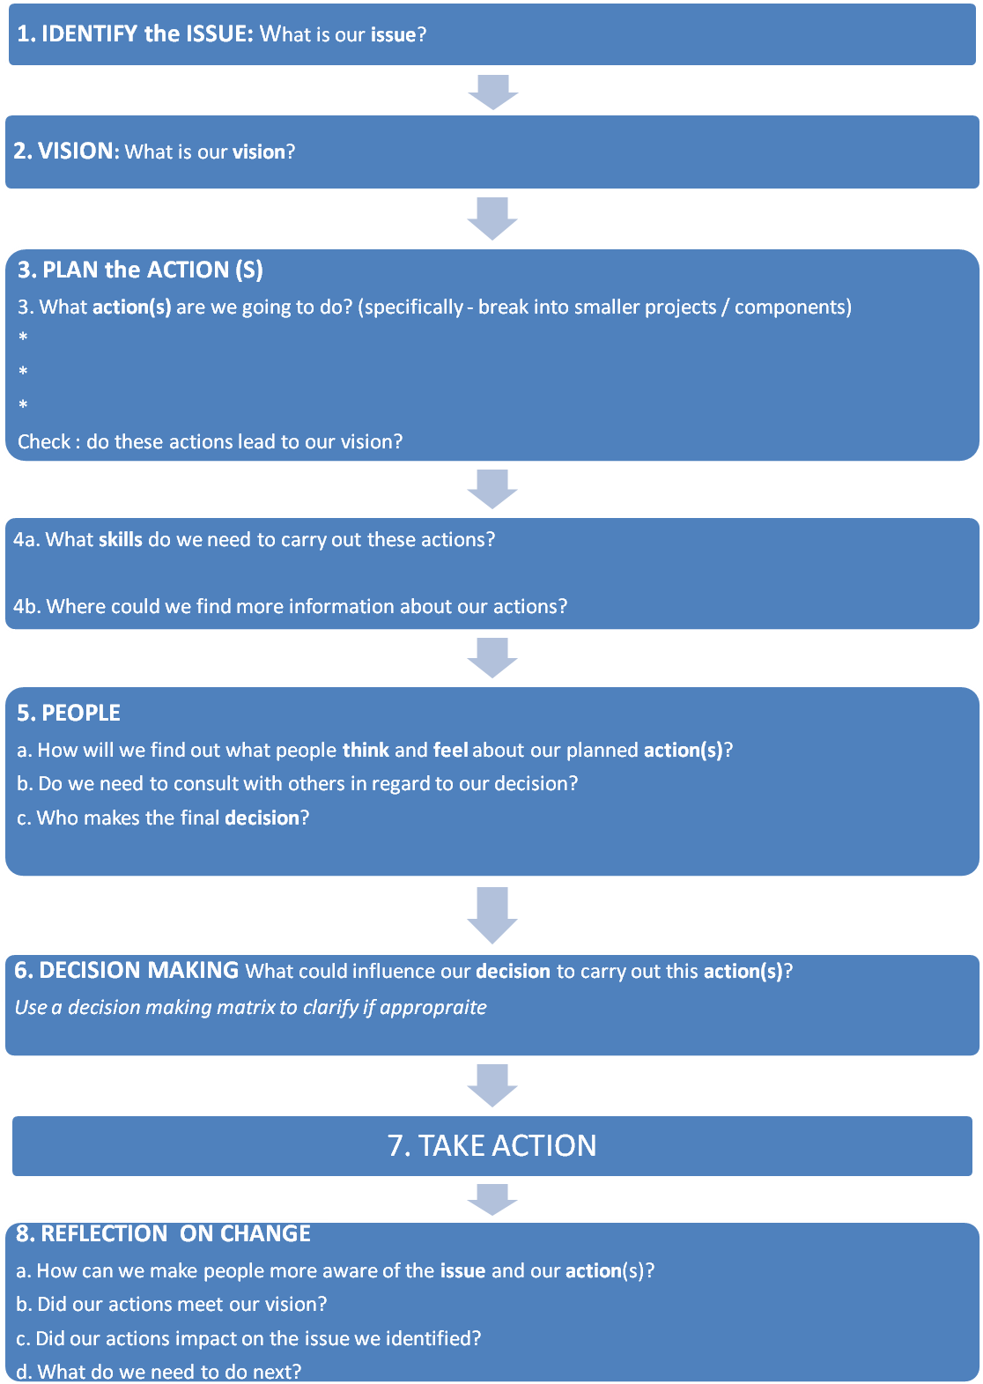

Action planning template
Example 2
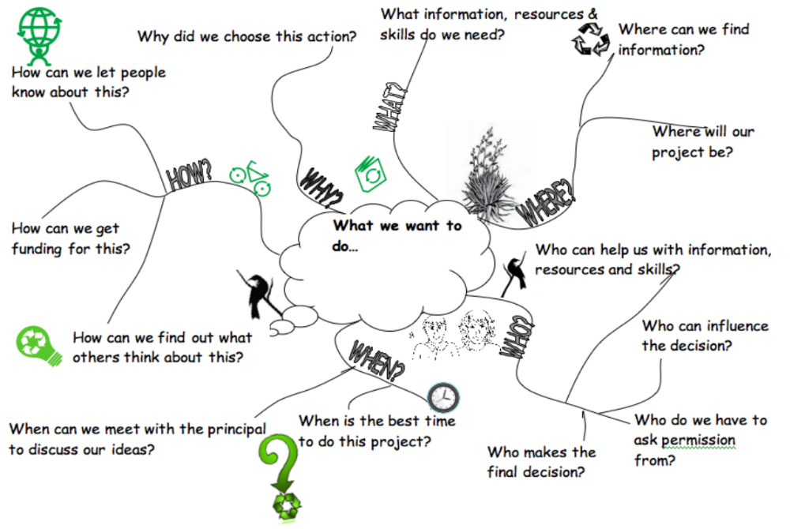
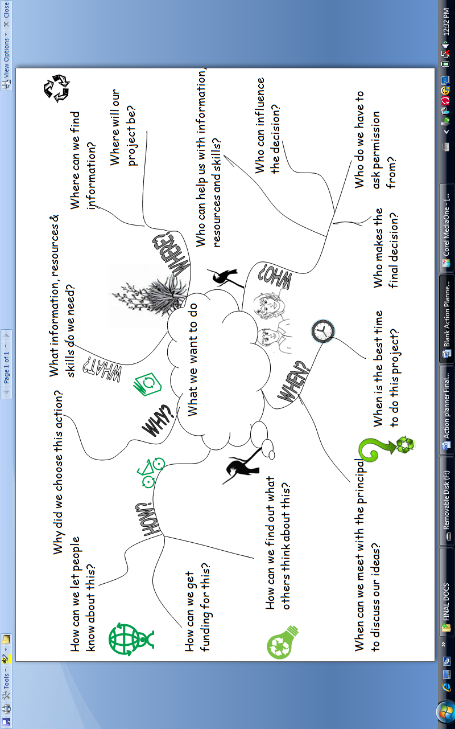
Action planning template
Example 3
What’s the issue?

What’s our goal?
What skills will we need?
Who could influence the decision?
Action
How will we find out how people think and feel about the issue?
How can we make people more aware of the issue?
What information do we need and where will we find it?
Evaluation of action
Evaluation of plan
Examples of student/teacher work
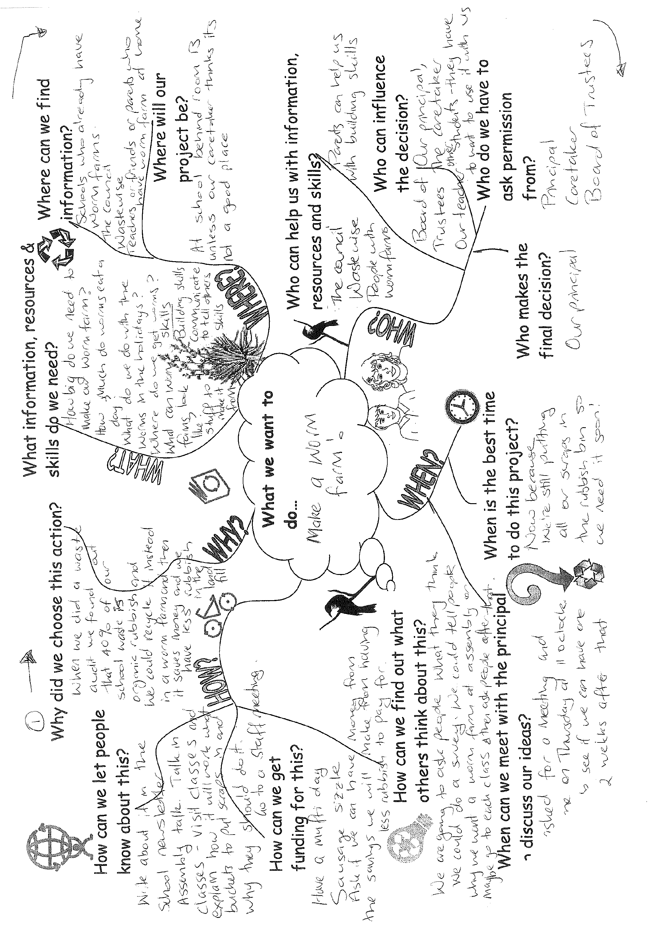

Next steps:  Are there new issues, investigations or actions that have arisen from this project?  Have students identified an aspect of taking action that they will focus on developing in the future? | Focusing inquiry  What are my student’s needs and abilities?  How do I know?  What is the next focus for our learning?
Things to think about / Tips for this resource…
- Make the ‘action plan’ a large shared document that is regularly updated and referred to.
- Add in a timeline so that tasks have an end.
- Refer back to the issue and vision to make sure that what you are doing addresses the issue.

