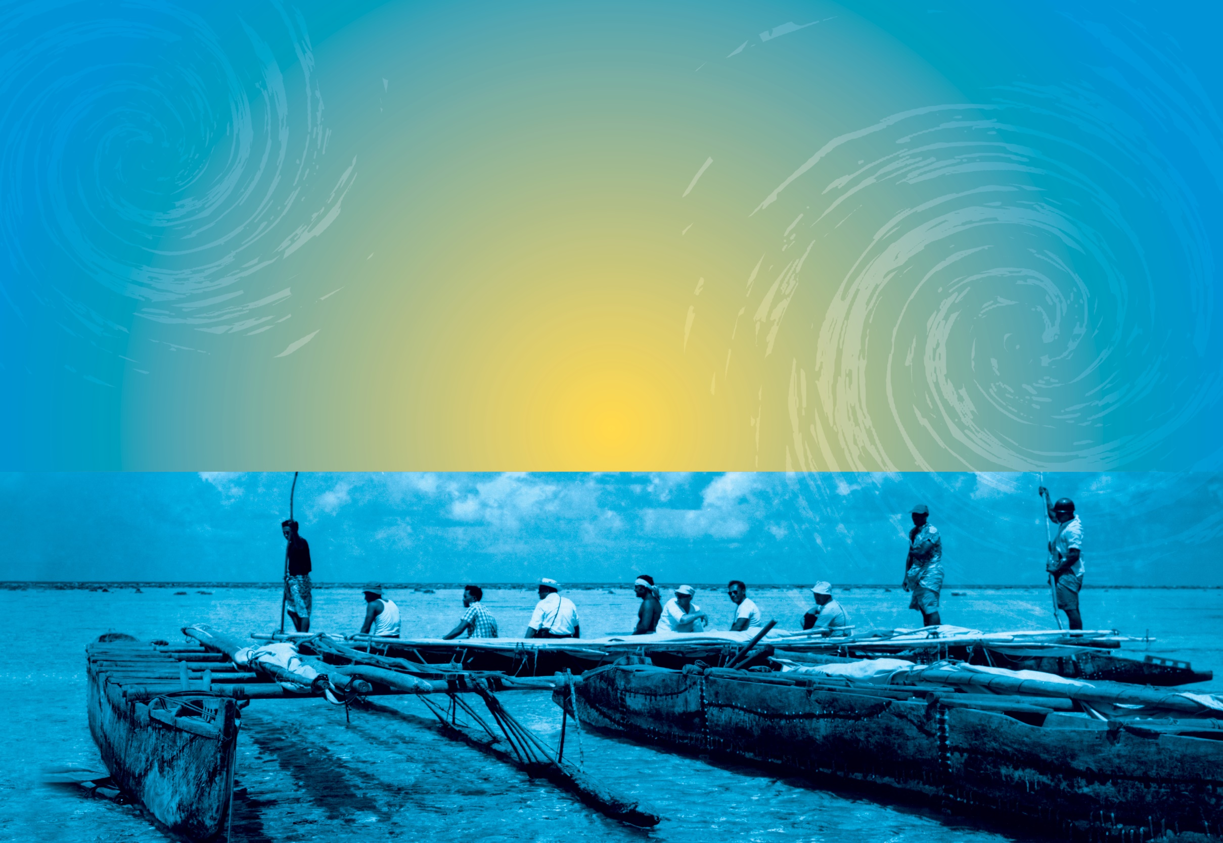
VĀIAHO O TE GAGANA TOKELAU
TOKELAU LANGUAGE WEEK
Education Resource 2016

LIHI O NĀ MATĀKUPU MA O LĀTOU PAHINA
CONTENTS PAGE

Kupu fakafetai – Acknowledgements 2
Taki o te Vāiaho o te Gagana Tokelau – Tokelau Language Week theme 3
Ko te Alafapeta Tokelau – Tokelau alphabet 5
Ko te lafoga –Basic pronunciation tips 6
Kupu fehoahoani – Helpful words 7
Gāluega fakatino mō te Vāiaho o te Gagana Tokelau – Activity ideas for Tokelau Language Week 8
Nā Tuhi Tokelau – Tokelau Books 16
Pepa fakahalalau o te Vāiaho o te Gagana Tokelau - Tokelau Language Week poster 17
Nā tino fakapitoa o te Vāiaho o te Gagana Tokelau - Tokelau Language Week champion 18
Fakamaoniga Aloakia – Certificate of Recognition 19

KUPU FAKAFETAI | ACKNOWLEDGEMENTS
We wish to acknowledge two Tokelau Wellington Leadership Group representatives Ioane Teao and Sale Siaosi for your guidance on the theme interpretations. We also thank Loimata Iupati and Filipo Lui for sharing your Gagana Tokelau and cultural expertise.

We have referenced the various contributions made to this resource by the Tokelau Wellington Leadership Group, Ministry of Education, Te Papa Tongarewa, the New Zealand Bible Society and Tokelau Bible Translation Committee, Coconet TV, the Tokelau Catholic Archdiocese, Epi Swan, Peato Tutu Perez, and the Atafu Elders of Porirua. Thank you to Vaitoa Baker who designed the language week poster and to Theresa Kele and Katrina Tamaira for the image sourced from Archives New Zealand.

E fakafetai lahi atu kia Lemalu Alexa Masina and Rebecca Browne for initiating this educational resource concept as part of Pacific language week celebrations in 2016. This resource hopes to ignite and grow Gagana Tokelau and aganuku learners of today and for generations to come.

TAKI O TE VĀIAHO O TE GAGANA TOKELAU
TOKELAU LANGUAGE WEEK THEME 2016

POKOTAU KI AU KAPUGA - KĒ MAU MAI TAU FOE
CHALLENGE THE SIZE OF THE SWIRLS MADE BY YOUR PADDLE
Strive for excellence and persevere to the end

This year’s theme is sourced from Alagākupu Tokelau (2011), a publication that records over 200 proverbs shared by elders and community members written by the Tokelau Wellington Leadership Group and the Ministry for Pacific Peoples. The guidance and interpretations on the theme and its meaning have been provided by Ioane Teao and Sale Siaosi with cultural guidance and language expertise on the sub-themes and resource provided by Loimata Iupati and Filipo Lui.

In essence, our theme focusses on the endurance and stamina needed to consistently paddle so that the canoe reaches its chosen destination. Supporting Tokelau heritage language and culture necessitates an insistent pursuit of excellence and a spirit of perseverance. All that we do should be upheld with dignity and honour.

This language week we encourage children, parents, families, community, learning spaces and workplaces to consider their own tāuivi ki te lelei (pursuit of excellence), tau loa (perseverance), mamalu ma te tāua (dignity and honour) in relation to Gagana ma te aganuku Tokelau (Tokelau language and culture). We offer these sub-themes in order to understand the essence of this year’s theme.

Let us consider our tāuivi ki te lelei, if we do not hold onto our foe (paddle) strongly the canoe will become aimless on the ocean. We encourage children, young people, parents, grandparents and communities to take every opportunity available to learn and teach gagana Tokelau and nā tū ma nā aga faka-Tokelau (Tokelau customs and way of life).

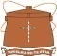 | TĀUIVI KI TE LELEI | PURSUIT OF EXCELLENCE
Tāuivi ki te lelei is the pursuit or search for excellence. We encourage people to undertake their own tāuivi ki te lelei in the context of Gagana Tokelau, aganuku Tokelau (Tokelau culture) and fakamateāga ō koe (your identity) to discover their own excellence. Pursue various opportunities such as learning cultural dance, arts, prayers, family genealogy and history.

TAU LOA | PERSEVERENCE
Like all pursuits of excellence there is a need to possess a spirit of tau loa (perseverance) to navigate challenges, changes, peaks and times when you need to change course or direction. This is also true when learning a language. We encourage all people to possess the heart of tau loa in all pursuits of learning, teaching and speaking Gagana Tokelau. Remain loto mau (steadfast), loto onohai (patient), loto alofa (compassionate), loto toa (courageous) and fāfia (proud), have fun learning together as a class, school, workplace, club, church or family.

MAMALU MA TE TĀUA | DIGNITY AND HONOUR
The pursuit of excellence in Gagana Tokelau has nā tū ma nā aga faka-Tokelau (Tokelau customs and way of life), aga i na mea fai (practices), vā feāloaki (inter-relationships) encompassing both traditional and cultural dignity and honour. Gagana Tokelau offers the opportunity to learn and speak as a gift passed on by our tupuna (ancestors and grandparents) and mātua (parents). By taking up the challenge to embrace the language and the culture, we too uphold mamalu ma te tāua. For those who possess the knowledge and skill of Gagana Tokelau we encourage you to also share ways you can pass on your knowledge and skills of the language, continuing the legacy of our heritage and ancestors.

KO TE ALAFAPETA TOKELAU
THE TOKELAU ALPHABET
The Tokelau Dictionary (1986) was published by the Office of Tokelau Affairs. It uses the following alphabetical order. Tokelau and English words are provided below to support your teaching and learning.
Aa  Alofa  (Love) | Ee  Epaepa  (Small sleeping mat for an infant) | Ii  Ika  (Fish) | Oo  Oketopa  (October) | Uu  Uluhina  (Male elders)
Ff  Faimātua  (Aunty) | Gg  Gāluega  (Work) | Kk  Kālena  (Calendar) | Ll  Lalaga  (Weaving) | Mm  Matau  (Fishing hook)
Nn  Niu  (Coconut tree) | Pp  Poto  (Knowledge) | Hh  Hiva  (Dance) | Tt  Tuluma  (Wooden fishing box) | Vv  Vaka  (Canoe)
A E I O U
F G K L M N P H T V

KO TE LAFOGA
BASIC PRONOUNCIATION TIPS

The Tokelau alafapeta (alphabet) is made up of fifteen mataituhi (letters). The letters of the alphabet are:
a, e, i, o, u, f, g, k, l, m, n, p, h, t, and v

There are five vaueli (vowels): a, e, i, o, u

These vaueli have the same pronunciation as other Pacific languages, including te reo Māori (Māori language). Vaueli can be short or long (the long vowel sound is indicated with a macron).
a, e, i, o, u (as in the English: are, there, three or two)
ā, ē, ī, ō, ū ( as in the English: father, egg, feet, thought, loot)

It is important that the short and long vowel sounds are used, as they distinguish between different words – e.g. mātua (mother) matua (to be a grown up).

Gagana Tokelau has ten konehane (consonants): f, g, k, l, m, n, p, h, t, and v

The Gagana Tokelau: The Tokelau Language Guidelines by the Ministry of Education provides the following explanation for how consonants are pronounced. This is much like in English, except that:
- ‘f’ is pronounced like ‘hw’ you make the ‘h’ sound at the back of your throat and then constrict the sound so that it becomes a ‘w’. As an example, fakalogo [to listen] sounds like ‘h-wa-ka-longo’
- ‘g’ is pronounced with a ‘n’ sound in front of ‘g’ – making it a ‘nga’ sound, as in te reo Māori, or the ‘ng’ sound from the English word ‘song’. As an example tagi [to cry] is pronounced ‘tangi’
- ‘h’ is pronounced like ‘hy’ in words such as hau [to come] which sounds like ‘hy-au’

For more resources to support learning in speaking Gagana Tokelau, check out the Ministry of Education’s resource, Muakiga! An introduction to Gagana Tokelau This resource has been designed for use by educators in New Zealand, including those who are new to or beginners at Gagana Tokelau themselves. In addition there are other reading material in dual languages (Gagana Tokelau and English) accessible on this link Unpacking the Books TKI Tokelau - Literacy Online - TKI

KUPU FEHOAHOANI
HELPFUL WORDS

KUPU FAKAFEILOAKI  SALUTATIONS  Mālō ni - Hello  E ā mai koe? - How are you?  Ko au e mālohi, Fakafetai - I am well, thank you.  Tulou - Excuse me  Ulu tonu mai -Welcome  Tōfā - Good-bye  Fakafetai lahi lele – Thank you very much  Ke manuia koe i te Alofa o te Atua - May you be blessed in God’s love  Ke fakamanuia e te Atua ia Tokelau - May God bless Tokelau |  | NA TAU O NA MAHINA  MONTHS OF THE YEAR  (TRADITIONAL AND LITERAL TRANSLATION)  Toe Palolo/Ianuali – January  Mulifā/Fepuali – February  Takaoga/Mati – March  Uluaki Hiliga/Apelila – April  Toe Hiliga/Me – May  Uluaki Utua/Iuni – June  Toe Utua/Iulai – July  Vainoa/Aukuho – August  Faka-Afu/Hetema – September  Kaununu/Oketopa – October  Oloāmanu/Novema – November  Uluaki Palolo/Tehema – December |  | NA AHO O TE VAIAHO  DAYS OF THE WEEK  Aho Gafua – Monday  Aho Lua – Tuesday  Aho Lulu – Wednesday  Aho Tofi – Thursday  Aho Falaile – Friday  Aho Tōnai – Saturday  Aho Hā – Sunday
NA KUPU E FAKAAOGA I NĀ AHO TAKITAHI – EVERY DAY EXPRESSIONS
Kai te manaia! – Awesome!  Te lelei ō koe – Well done!  Te lelei ō koe Iohefo! - Well done Iohefo!  Ko au e fehoahoani atu kia te koe – I will help you  Fakatakitaki ki ei – Give it a go |  |  |  | Io fakamolemole – Yes please  Hēai fakafetai – No thank you  Manuia te po Zion – Goodnight Zion  Kā fai te tātou tatalo – Let us pray  Kā uhu te tatou pehe - Let’s sing our song

GĀLUEGA FAKATINO MŌ TE VĀIAHO O TE GAGANA TOKELAU
ACTIVITY IDEAS FOR TOKELAU LANGUAGE WEEK 2016

There are lots of great ways to celebrate and participate in Tokelau language week in 2016. The theme of excellence, perseverance, honour and dignity embraces the importance of using Gagana Tokelau everyday through various forms.

Here are some activity ideas below:

TĀUIVI KI TE LELEI | PURSUIT OF EXCELLENCE

Pursuing excellence within Gagana Tokelau will take various efforts and opportunities so embrace the Gagana by finding ways to use the Gagana everyday within your kāiga (family). For brand new speakers, it might be as simple as using phrases like ‘Mālō ni’ (Hello), ‘Ulu tonu mai’ (Welcome), ‘E ā mai koe?’ (How are you), and ‘Ko au e manuia, fakafetai’ (I am well, thank you).

You could also go about learning to use some of these expressions while undertaking everyday activities - like dinner preparation, reading time before bedtime or during a coffee meeting with a work colleague.

For instance:
- Ko au e fehoahoani atu Ana - I will help you Ana.
- E ā mai te ākoga i te aho nei Tekafa? – How was school today Tekafa?
- Mānaia tau faitautuhi Te Uluaki - You read very well Te Uluaki!

Museum of New Zealand - Te Papa Tongarewa Collections Online
Knowing more about your cultural heritage helps to build your Tokelau identity. Browse through the Collections Online website to see pictures of the many traditional and contemporary Tokelau treasures held in Te Papa’s Pacific Collections. Talk about the significance these objects have to you personally, or find out why they are important to the people in your family, groups and community.

Bring in your treasures (or a photo if that is not possible) to share with others in your class or organisation. The more we explore, learn and talk about things that are significant to our culture the more we know.

Some examples of traditional treasures include:

- Tuluma (fishing box or container)
- Te kie tau (woven Tokelau mat)
- Tokelau traditional tools (A carver's story about traditional Tokelau tools)

Grow an environment for Gagana Tokelau

In order for us to thrive in the pursuit of excellence with Gagana Tokelau we need the right conditions and environment to help us. Discuss together (as students and educator, as peers, as a family, as professionals) what you are already doing for Tokelau language in your kāiga (family), āoga (school), lotu (church) or fakalāpotopotoga (community organisation). Plan how you could improve your spaces, resources, practices, or policies further.

For instance - in the ECE and school setting a teaching team may discover that while they are using the language, it is only as a language of instruction - e.g. tū ki luga (stand up) or nofo ki lalo (sit down).

You might aim therefore to:

- Build more descriptive or conversational type phrases into your programme
- Better utilise the language expertise existing in your community (elders, community leaders, parents, organisations and children) to help you to do this
- Create a safe space for educators to try out new ways of using Gagana Tokelau, and to build their confidence
- Play board games and cards using Gagana Tokelau
- Plan times where you try your best to speak only Gagana Tokelau

For more information check out the Ministry for Pacific Peoples Mind Your Language Tokelau resource

Fuaikupu mai te Tuhi Paia (Verses from the Bible)

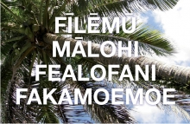
Spiritual beliefs and values are an integral part of the lives of Tokelau people. Gagana Tokelau is celebrated in communities through alofa (love), faka-te-agaga (spirituality) and fakatuatua (faith). Whether through traditional beliefs and values, exploring our legends, or celebrating and coming together as communities in churches, our beliefs and values help us to learn more about our language, culture and identity.

Identify the different times that prayers can be held in your homes or workplaces. Share simple bible verses or prayers you have learnt or are learning. Check out the Bible Society of New Zealand’s published booklet of Gagana Tokelau bible verses.

We have selected two examples of verses which relate to the Vāiaho o te Gagana Tokelau theme for this year.
Ihaia 40:31  Kae ko kilātou e fakamoemoe ki te Aliki ka fakafougia to lātou mālohi. Ka fakahekeheke māualuluga kilātou i nā kapahau e vē ni āeto; ka fētutuli kilātou kae hē matapogia. | Isaiah 40:31 NIV  But those who hope in the Lord will renew their strength. They will soar on wings like eagles; they will run and not grow weary, they will walk and not be faint.
Iohua 1:9  Fakamākeke ma loto tetele. Koutou nahe mātataku, ma ia koutou nahe loto vāivai, auā ko te Aliki te koutou Atua, e fakatahi ma koutou pe ko fea lava e olo koutou ki ei. | Joshua 1:9 ESV  Be strong and courageous. Do not be frightened, and do not be dismayed, for the Lord your God is with you wherever you go.

TAU LOA | PERSEVERENCE

Gagana Tokelau goals (daily, weekly, monthly and yearly)

Set goals to help your planning, learning and perseverance in Gagana Tokelau. These could be personal goals, goals as a class, workplace or family.

For example:
- learn 5 new words daily
- learn 5 phrases weekly
- learn some Tokelau songs and dances for an assembly or celebratory event
- learn a traditional art and craft and display it to share with friends and family

Alagākupu (Proverbs)

Alagākupu provide opportunities for engagement, discussion, sharing of knowledge and learning. Use one of the alagākupu from this year’s Tokelau language week poster which explores perseverance:
- Tuia te pō ke ao (Work through the night, until dawn, until sunrise. The children are waiting for their catch)
- Tūtia te au ke māmā (Be patient and tolerate the currents)
How does this relate to perseverance and learning Gagana Tokelau? With a Tokelau language buddy to support your learning - grandparent, parent or community member, investigate or research other alagākupu that explore perseverance.

Stories, legends and histories from your village connections

Research and investigate stories, legends and histories from your village connections or connections of Tokelau peers in your class or workplace where tau loa (perseverance) was displayed. Ask family members if there are stories where tau loa was displayed to meet a goal or to reach a destination or aspiration. These stories might even be about migrating from Tokelau to Aotearoa New Zealand.

Learning through na Pehe Tokelau (Tokelau songs)

Learning pehe (songs) can help with language learning and development, it also helps us learn about stories, culture and practices special to Tokelau. You could find out stories, legends, histories or songs from your village connections where tau loa was displayed from someone in your family or community. You may have parents and grandparents in your school, songs available online, or staff within your organisation that may be able to support you to learn pehe Tokelau.

The ‘Ko Tonuia’ song was composed by Tioni Vulu and ‘Kaimoana’ is by a well-respected elder Lui Kena Soane. The translation and meaning of these songs is provided by Coconet with a rendition sung by Vaniah Toloa, Jewel Tuitama and Gideon Toloa. The Coconet TV clip can be accessed here: http://www.thecoconet.tv/poly-songbook/tokelau-medley/

KO TONUIA  Ko Tonuia i Falefitu  Nonu ma Alo i Falefa  Takoto Kava i Faleiva  Ko Palega o Fenua  Tokelau o o o  Tokelau o o o  Tokelau o o o X2 | The song is a salutation of the islands of Tokelau and their chiefs;  Tonuia lives in Falefitu (Atafu atoll)  Nonu and Alo live in Falefa (Nukunonu atoll)  Kava lies in Faleiva (Fakaofo atoll)  It is the beauty of the land  Tokelau o o o  Tokelau o o o  Tokelau o o o X2
KAIMOANA  Kaimoana Kaimoana faiva e ifo ki tupua  Kaimoana Kaimoana faiva e ifo ki tupua  Kana kamata mai kitaua i na mulipapa e  Ke tau ki te takele moana e | Edible resources of the ocean and related methods used to harvest them are connected with the spirit world.  Edible resources of the ocean and related methods used to harvest them are connected with the spirit world.  I wish we could have started from the shallow edge of the reef.  Until we reach the bottom of the seabed.
MAMALU MA TE TĀUA | DIGNITY AND HONOUR

The kāiga (family) plays a very important role in aganuku Tokelau. Relationships we have with our kāiga teach us various cultural norms and practices such as how we treat each other through fakaaloalo (respect), vā feāloaki (inter-relationships), maopoopo (inclusion) and alofa (compassion), these values help us with social awareness and how we engage in our respective families and communities. These all contribute to how we show pride, dignity and honour for the people we care about, our kāiga and community; they can even connect us to the specific norms of our respective village cultures and protocols.

Mamalu ma te tāua in the class, home and workplace

Using the theme of mamalu ma te tāua, find out what Tokelau words your class, home or workplace you might like to use during Tokelau language week or to use and learn over the year to showcase dignity and honour to those around you. Use Unit 1 from Muakiga! An Introduction to Gagana Tokelau or invite someone who can teach you Gagana Tokelau as an activity for your class, family or workplace.

Plan a Tokelau event or activity to show your pride

Show your pride and celebrate by organising a Tokelau event where you can share Gagana Tokelau and other elements of your Tokelau culture (e.g. food, dance, dress, music) with people from different cultural backgrounds.

Invite elder, grandparent, or leader

In the context of excellence you may wish to invite a local Tokelau elder, grandparent, and parent or community leader to share stories and histories of Tokelau, the language, a traditional artefact and its importance to the culture or to teach a cultural dance or nursery rhyme.

Tokelau pride

Tokelau is a New Zealand territory and is one of the constitutional countries of the realm of New Zealand. There are over 7,000 Tokelau people in New Zealand with almost 1,400 people living in Tokelau. Did you know that Wellington has the highest population of Tokelau people in New Zealand and the world? There are well established Tokelau communities and families in Auckland, Rotorua, Taupo, Manawatu, and Dunedin.

Many people show their pride and honour by performing their national anthem; this is true also for the people of Tokelau. Below are the lyrics to the Tokelau national anthem. Is there a time where you think singing the Tokelau national anthem could be sung during Tokelau language week?

Click on the link to find out more information on the Tokelau flag.

Click on the link to listen to an audio of the Tokelau National Anthem from the Government of Tokelau’s website.

Lyrics to the Viki o Tokelau (Tokelau National Anthem).

Te Atua o Tokelau  Te Atua o nuku, te Atua o Tokelau  Fakamanuia mai ia Tokelau  Puipui tauhi mai kō i to filēmū  Toku fenua, tau aganuku  Tau fuka ke āgiagia  Lototahi, tūmau i tō fakavae  Tokelau mō te Atua  Te Atua o Tokelau | Tokelau Anthem  The God of Tokelau, The God of villages, the God of Tokelau  Do bless Tokelau  Carefully tend within your peaceful care  My land, your custom  Your flag that’s waving  Of one mind, stand firm on your foundation  Tokelau for God  the God of Tokelau

Being a Tokelau person in Aotearoa New Zealand

Census 2013 recorded 7,176 Tokelau people living in New Zealand and make up 2% of the Pacific population in New Zealand. Some people have migrated here, while a majority have been born here as 2nd, 3rd or 4th generation New Zealanders.

Discuss how you feel being Tokelau in Aotearoa New Zealand. Do you think this is the same or different to being Tokelau in Tokelau? Has being Tokelau in Aotearoa New Zealand changed for you over time? What helps you to maintain or grow your Tokelau identity in this country?

Speak Gagana Tokelau through Nā Tatalo (Prayers)

Spirituality is an important part of the Tokelau culture with faith being practised in different forms either in prayer, attending church services or through hymns. The Tokelau Catholic Chaplaincy, Archdiocese of Wellington published a bilingual Tokelau and English Prayer Book in 2012 and we offer this prayer as an example.

Recital of prayers in Gagana Tokelau is one useful way to encourage using Tokelau language with children and as a family.

Ko aho takitahi te Aliki e,  e tolu aku fakanau;  Ke kitea manino koe;  Ke alofa lahi pea ki a te koe;  Ke taumulimuli atili lava ki a te koe, i aho uma. | Day by day dear Lord,  three things we pray;  to see you more clearly;  To love you more dearly;  To follow you more nearly, day by day.

NA TUHI TOKELAU
TOKELAU BOOKS

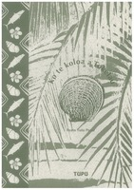
There are a limited number of books written by Tokelau authors over the last 30 years. We recommend these publications:

KO TE KOLOA A TOKELAU - A TREASURE OF TOKELAU
This is a publication written in the Tokelau language in 1992 by the late Peato Tutu Perez. It shares in Gagana Tokelau the traditional knowledge relating to the mother of pearl shell. This shell has much significance in the Tokelau culture. You will see Tokelau women wearing necklace cut from the mother of pearl shell, it is also used to make fishing lures.
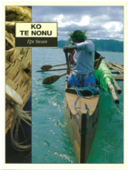
*Ko te koloa a Tokelau, by Peato Tutu Perez (Book cover)
KO TE NONU – THE NONU
Epi Swan has written this book in collaboration with elders, community leaders and the Tokelau Petone community. It shares the story of a Tokelau-New Zealand community that is preserving Tokelau heritage culture and language through the ‘Nonu’ - the name gifted to this traditional Tokelau canoe. The parts of the canoe are named; fishing techniques are shared, the names given to the various aspects of traditional fishing lure and other cultural practices that gives insight into Tokelau traditional skills shared with New Zealand born children.
*Ko te Nonu, by Epi Swan (Book cover)

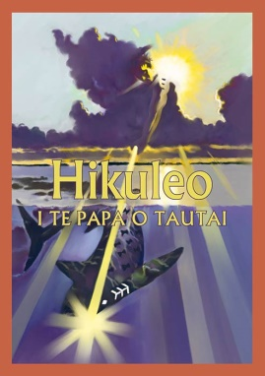
HIKULEO I TE PAPA O TAUTAI - ECHOES AT FISHERMAN’S ROCK
This is the first traditional Tokelau fishing book written by Elders of Atafu Matauala organisation in Porirua, Wellington. It was first published in Gagana Tokelau in 2008 with an English version published in 2012 by Dr Iuta Tinielu and Anthony Hooper. This book describes various traditional fishing methods and techniques and records Tokelau cultural dance songs from Atafu.
*Hikuleo i te papa o tautai, by Elders from Atafu Atoll (Book Cover)

PEPA FAKAHALALAU O TE VĀIAHO O TE GAGANA TOKELAU
TOKELAU LANGUAGE WEEK POSTER

This year’s Tokelau Language Week poster was developed by the Ministry for Pacific Peoples with language assistance provided by the Tokelau Wellington Leadership Group. We commissioned the assistance of a Tokelau illustrator and graphics designer with a photograph was sourced from Archives New Zealand.

The Tokelau Language Week 2016 poster, update on events for Vāiaho o te Gagana Tokelau and this resource is available on the Ministry for Pacific Peoples website www.mpp.govt.nz

NA TINO FAKAPITOA O TE VĀIAHO O TE GAGANA TOKELAU
TOKELAU LANGUAGE WEEK CHAMPIONS

Everyday efforts and environments nurture, invest in, and develop Gagana Tokelau. That means there are many people, across our communities, who are our champions of Gagana Tokelau – whether children, young people, adults and elders, our role models or celebrities.

This Tokelau Language Week, the Ministry for Pacific Peoples want you to acknowledge these important people, and share the messages they have regarding Vāiaho o te Gagana Tokelau.

How do I get involved?

Step 1: Put forward a person from your community who you think should be recognised in 2016. Discuss why you believe this person is a Gagana Tokelau champion.

Step 2: Utilise the certificate template on page 19 or 20 (or create your own version that better reflects you, or your centre, school or organisation). Make sure to write or draw the reasons why you have selected your champion on the certificate.

Step 3: Present your certificate to your champion, telling them why they are your Gagana Tokelau champion in 2016.

If your champion can’t receive their certificate in person, you could post it (via email or mail) along with a letter outlining your reasons.

Step 4: With your champion’s permission, post a picture of them on social media (Facebook, Instagram or Twitter), along with a short explanation. Make sure to include the hashtag #TokelauLanguageWeek

For example: Tana Tokelau is our Gagana Tokelau champion. She is a grandmother of 5 and teaches Gagana Tokelau to the children in her family every Saturday morning. She encourages parents and grandparents to find time to teach their children Gagana Tokelau, and have fun doing it. #TokelauLanguageWeek

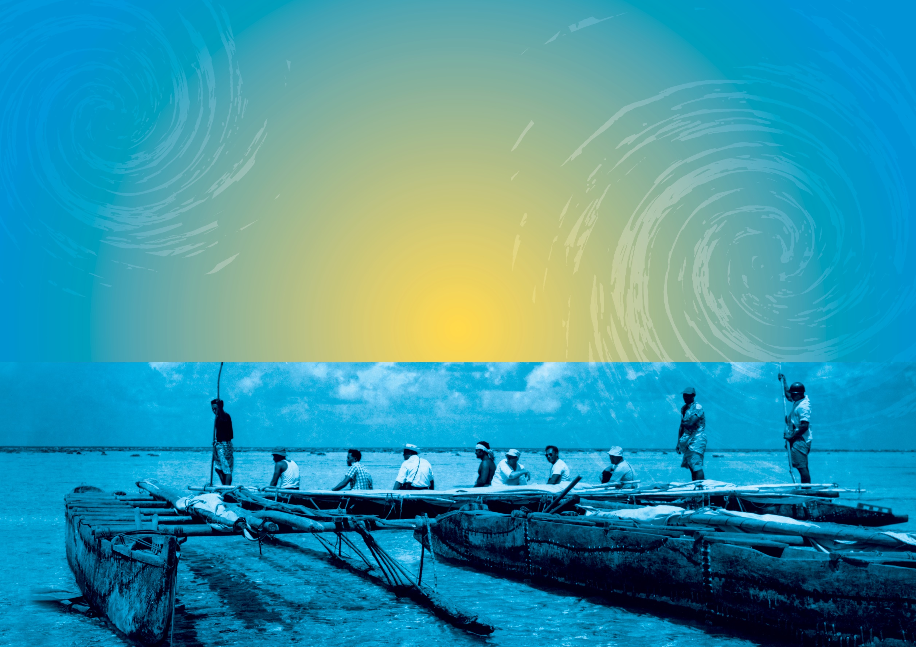
Step 5: Use the hashtag to search out other Gagana Tokelau champions, recognised by people all around Aotearoa New Zealand. Make sure to check out champions featured on the Ministry for Pacific Peoples Facebook page throughout Language Week too.
FAKAMAONIGA ALOAKIA
Kote fakamaoniga tenei e kavatu mate fafia kiā

_____________________________________
Mo a latou galuega i te hapotiga o te Vāiaho o te Gagana Tokelau in 2016

E ko/ma aloakia te tino tenei aua:

Signed:

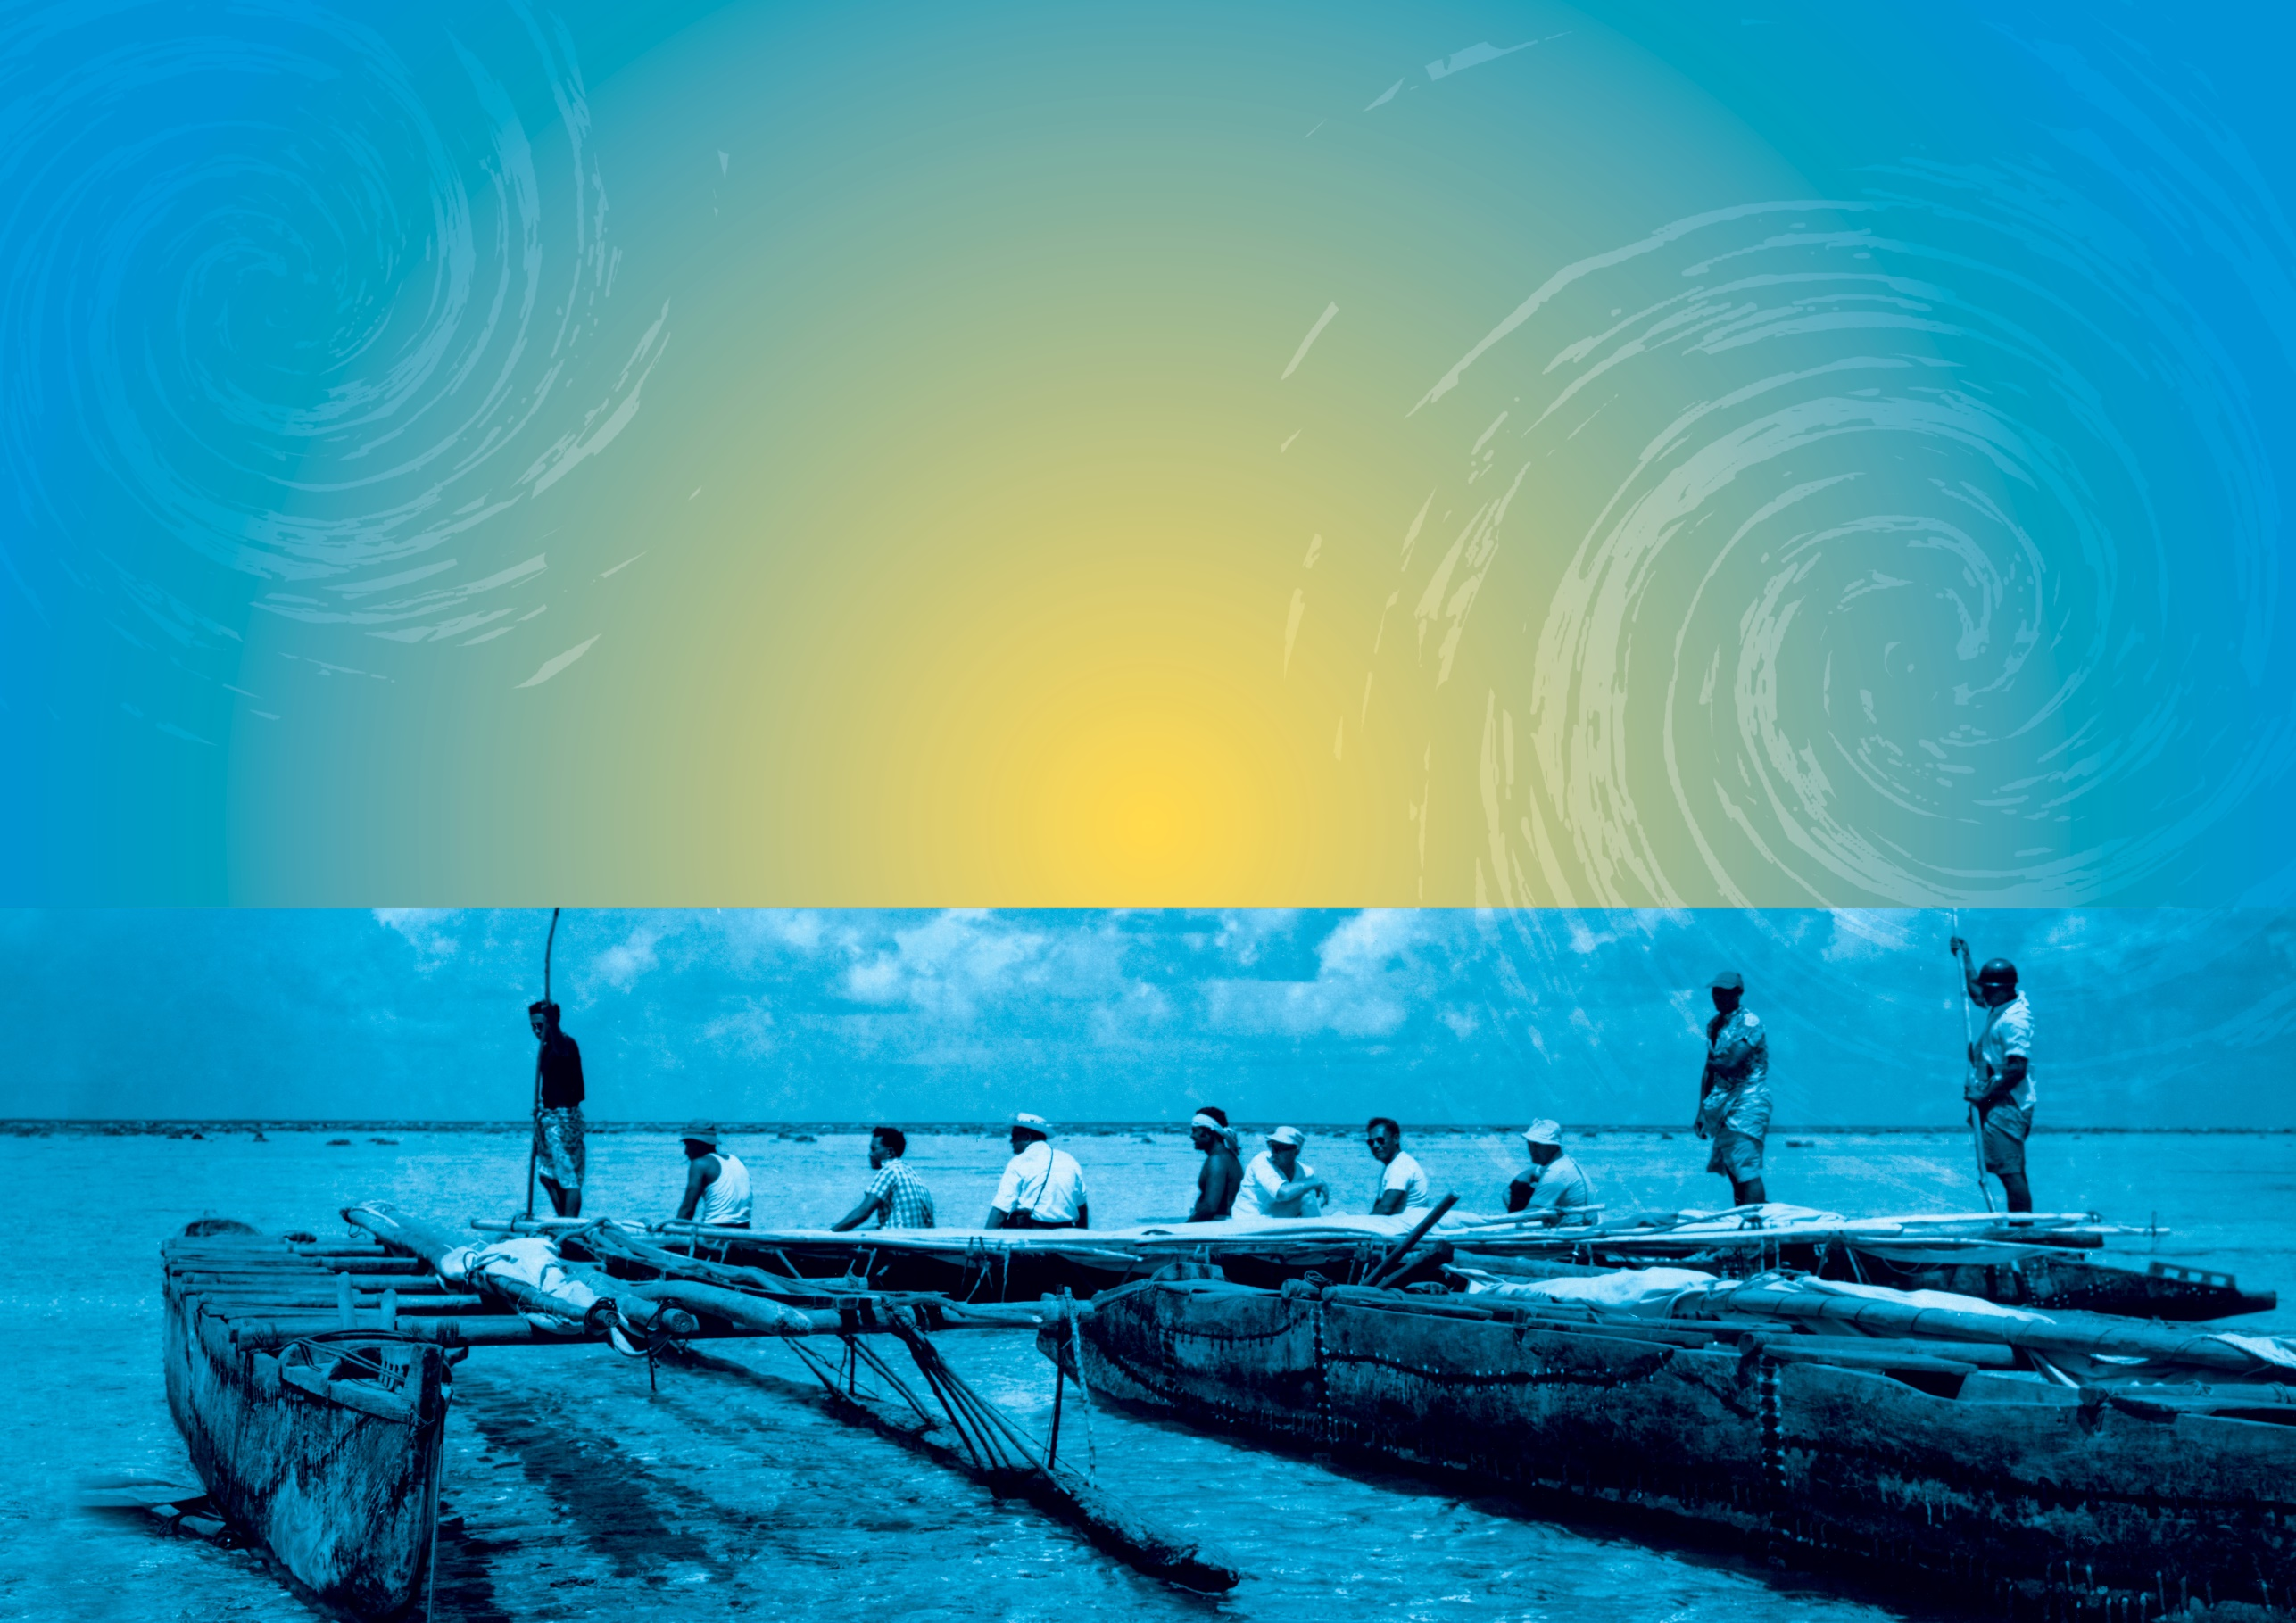
CERTIFICATE OF RECOGNITION
This certificate is awarded with pride to

_____________________________________
For their work to support Vaiaho o te Gagana Tokelau in 2016

I/we recognise this person because:

Signed:

Published in October 2016
By the Ministry for Pacific Peoples
PO Box 833
WELLINGTON, 6140
NEW ZEALAND

