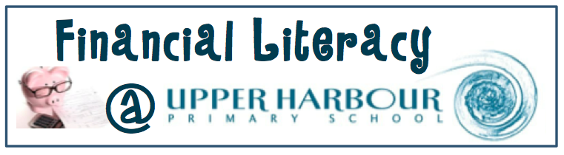
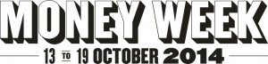
Money Week is a nationwide week of events that motivates Kiwis to look at their financial situation and get their money fighting fit.
As a country, our money metabolism is a bit sluggish and we could all do with a detox and some toning up. Regardless of the level of your financial fitness, Money Week offers something for everyone, from seminars for savings sloths through to investment planning for the money marathoners
Money Week is brought to you by the Commission for Financial Literacy and Retirement Income and powered by Sorted.
For money week tips visit http://prezi.com/3cdobvxnlxbb/fighting-fit-webinar/
What is happening at Upper Harbour Primary School?
At UHPS we are celebrating money week!! We have a number of different activities throughout the week to help everyone become excited about money!!

For the students: Values assembly- Introducing money week, play shop, money games on the computers and ipads, piggy bank craft, inspirational posters

For the teachers: Daily financial capability advice, resources to use with students

For the community: Inspirational posters, Sorted booklet- Saving sent home, Survey to be completed- to help us know how we can help you! Click HERE to complete the survey.

Saving- A little becomes a lot over time
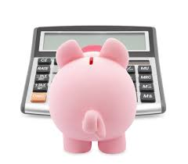
This week your child will bring home a Sorted booklet all about Saving. Please read this booklet and have a go at completing the savings plan to see if you can achieve a savings goal you may have.
Tips for successful saving...
- Make a plan
- Saving helps you get what you want
- Keep your savings account seperate to your everyday account
- Set realistic goals
- With compound interest your money will grow the longer you leave it
Visit sorted.org.nz and try out their savings calculator.

What have our students been learning?
The Little Learners students have been learning how to sequence money. The children began by trying to put the money into sequence. It was tricky!!

Then we looked at all the different money and it’s value. The children created their 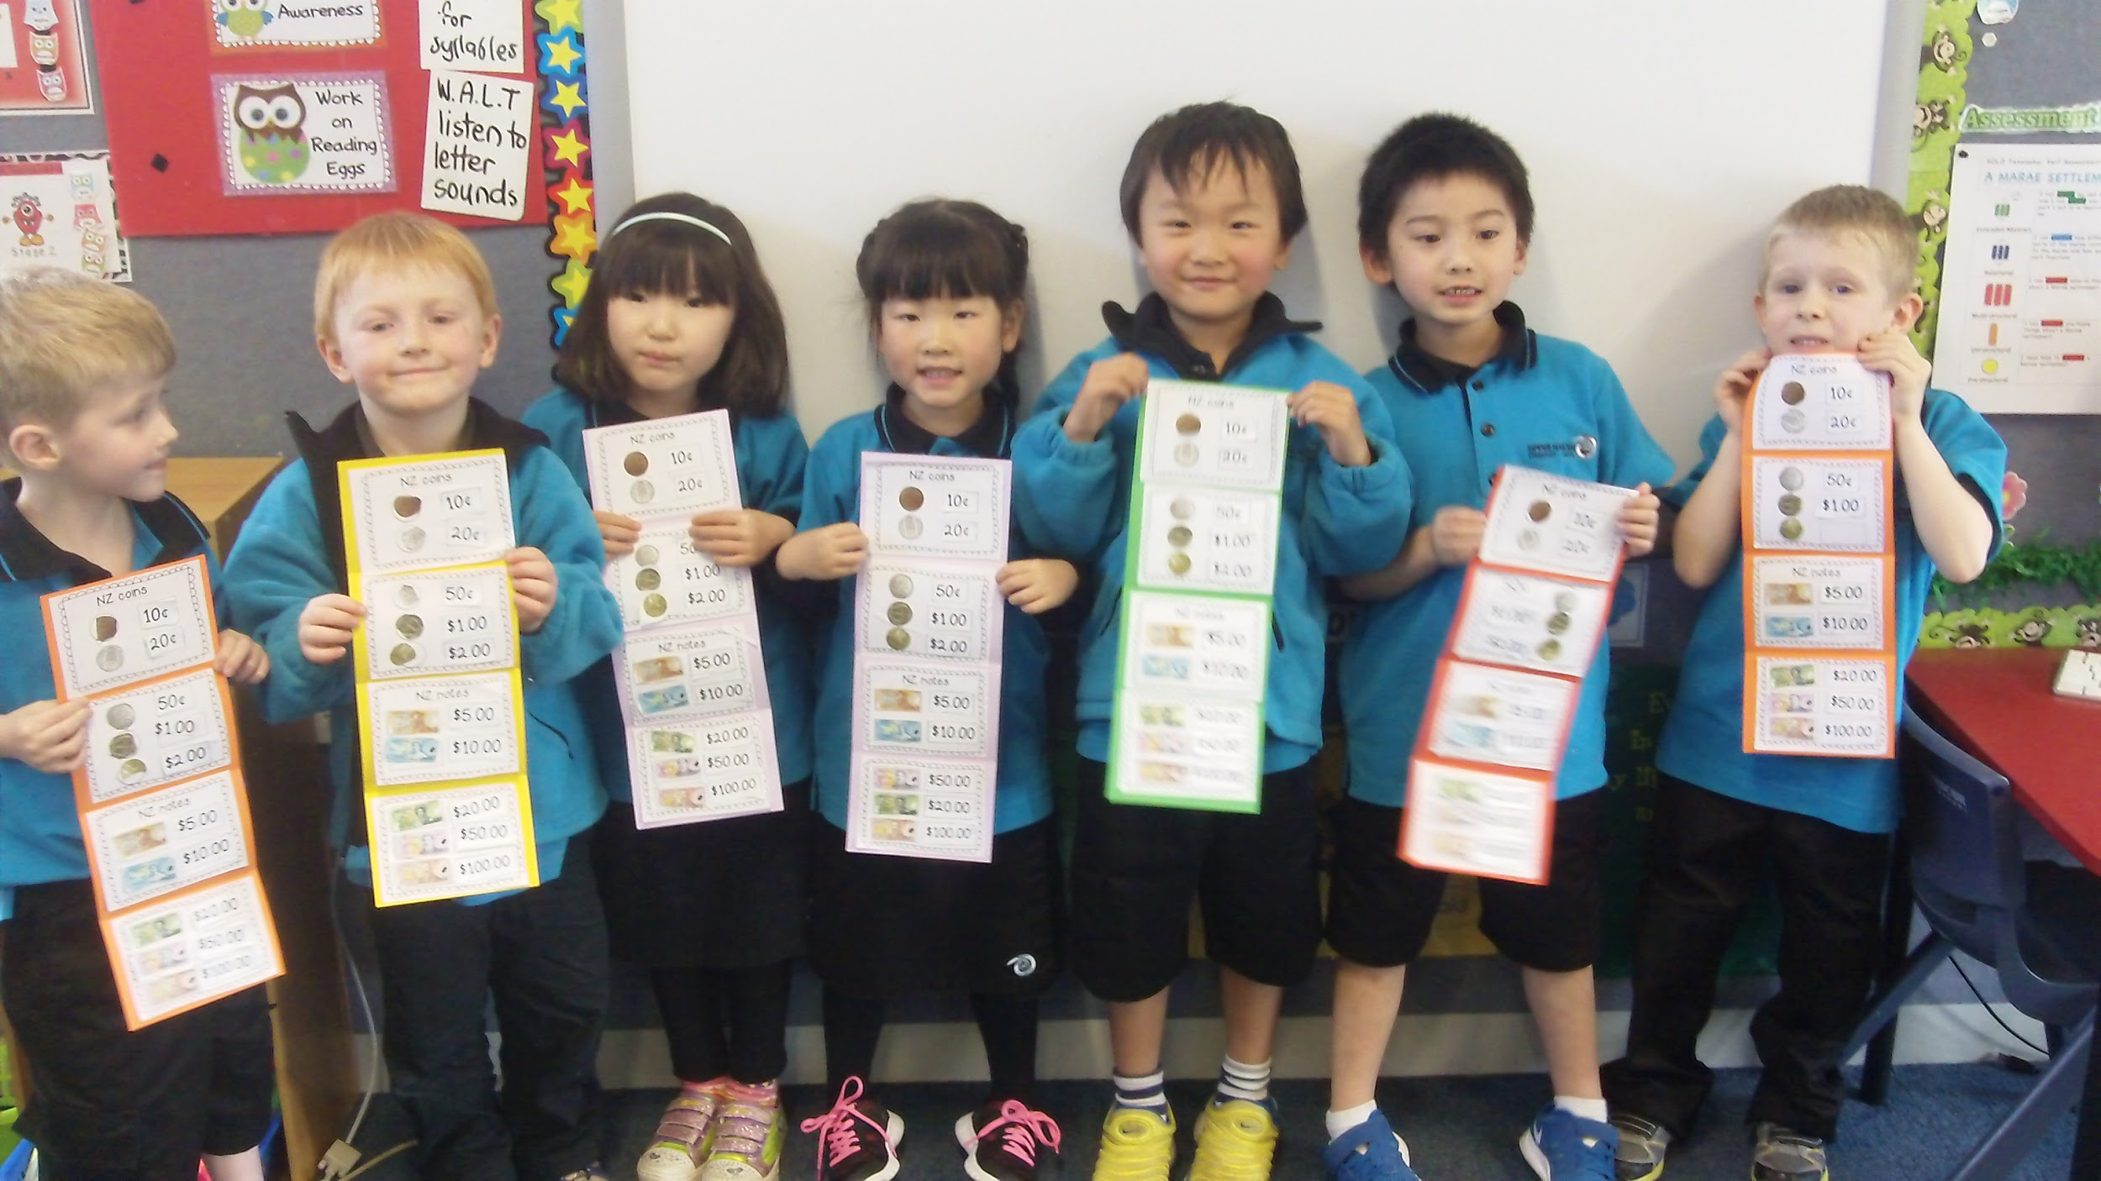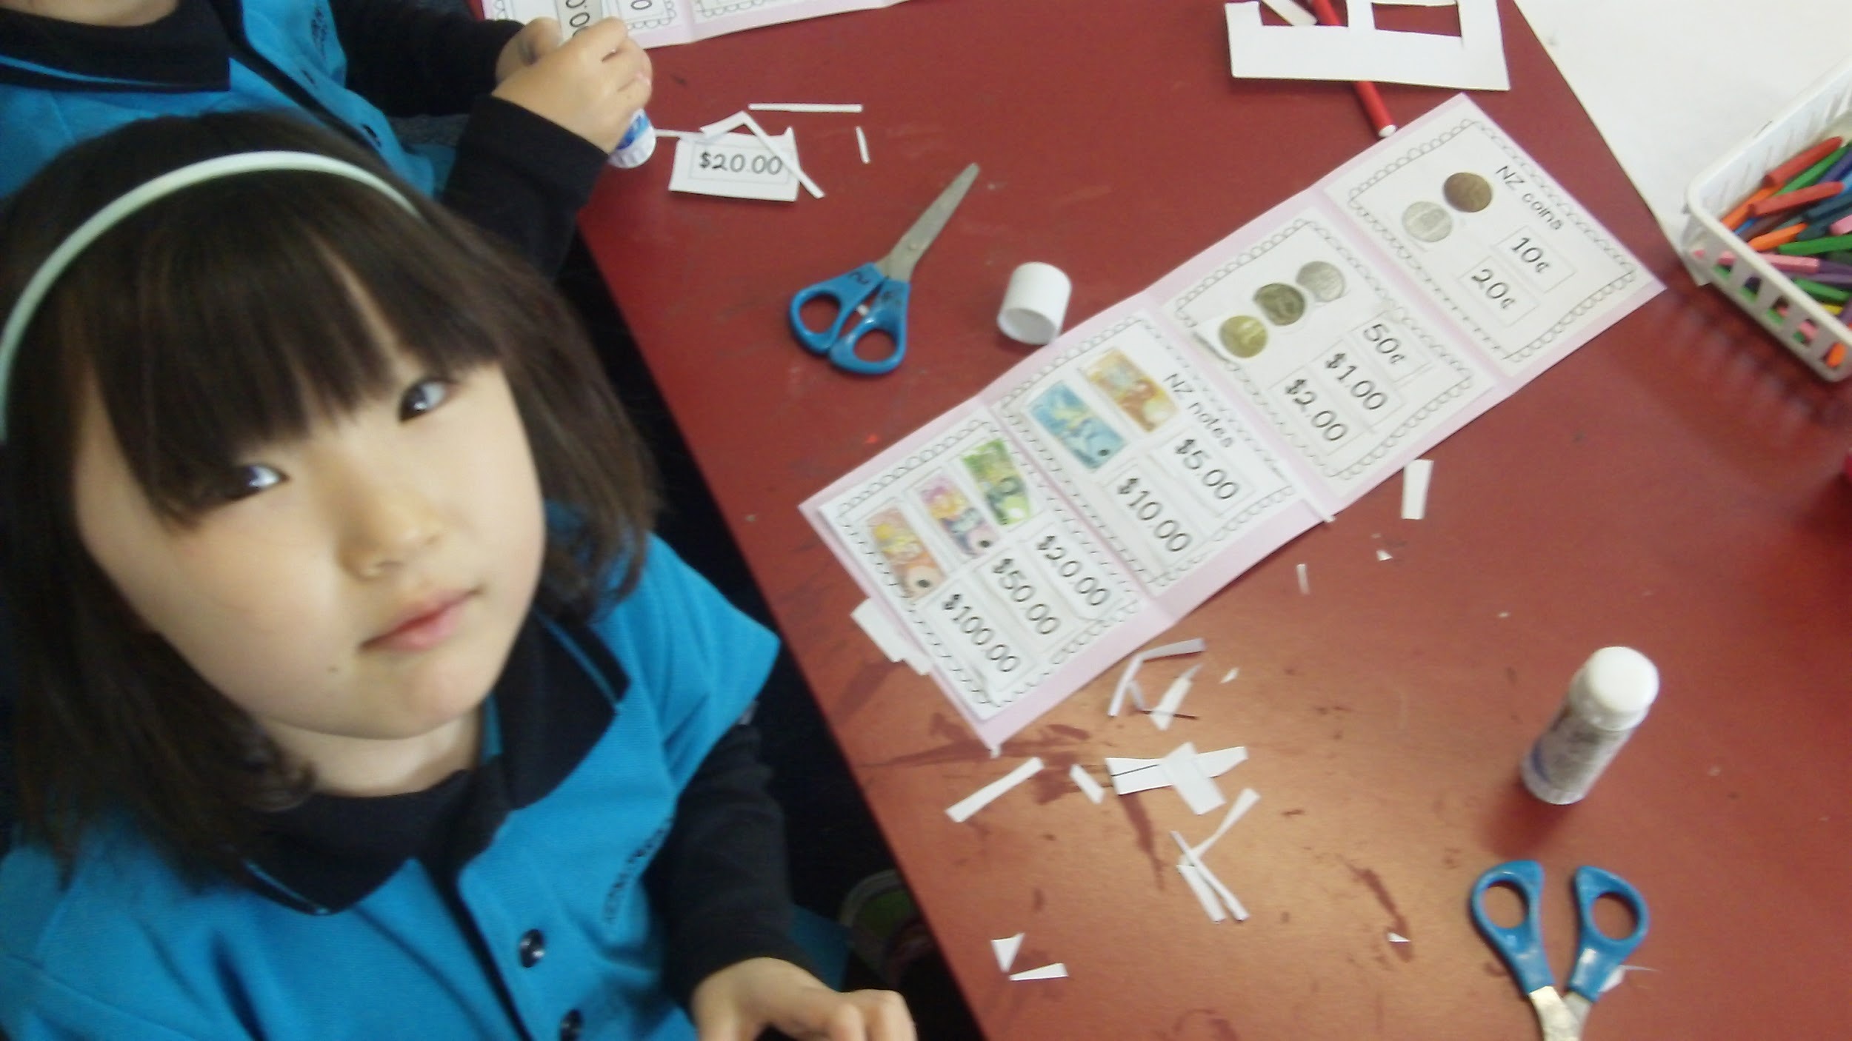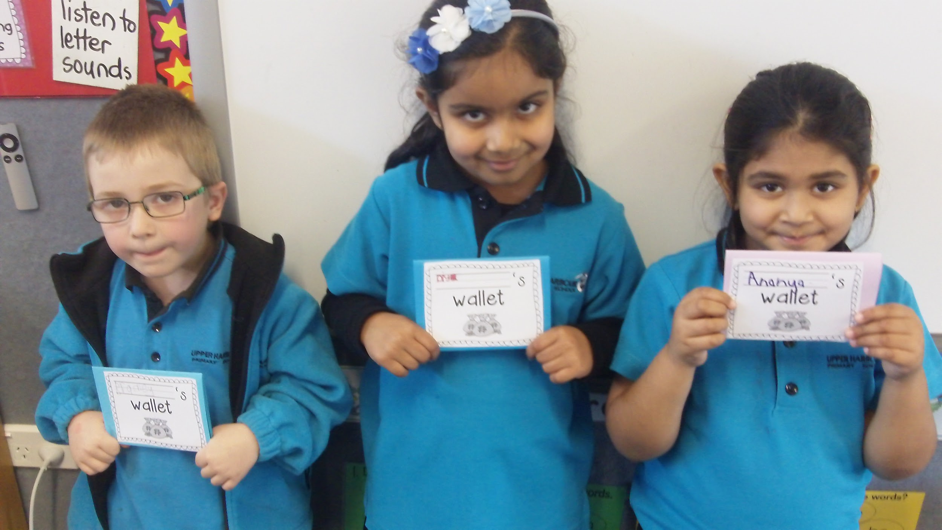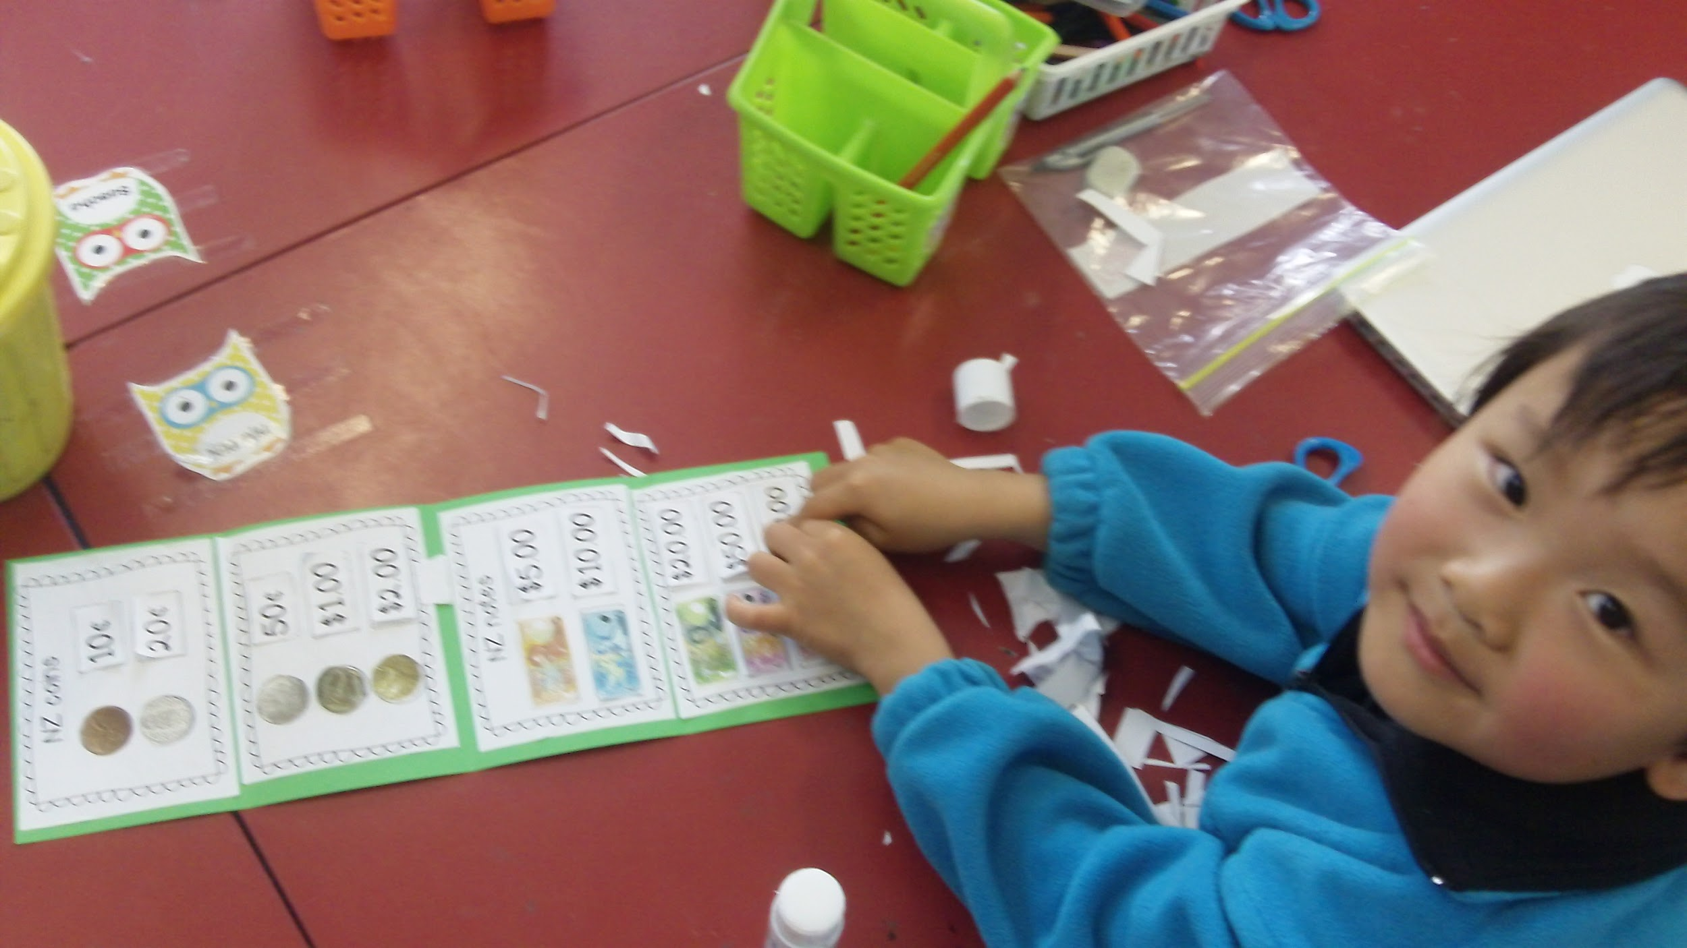own money wallets and sequenced the money in the correct order. They learnt that 10c has the smallest value and $100.00 has the largest value.
See some of the work we’ve covered this term at: http://uhpsroom102014.blogspot.co.nz/p/financial-literacy.html
Extra MONEY News…
“Do not save what is left after spending, but spend what is left after saving. “Warren Buffet”
Are you interested in becoming more financially capable?
Thursday 30th October- Free lecture series at Massey university-See the 10 top scams that make you part with your money without you knowing. If you are interested please ring 413 7233 to book a place.
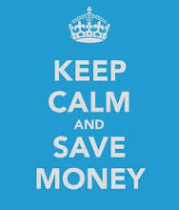
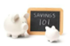Money Tips:
- Save from every pay: That hand-mouth-unease
https://www.sorted.org.nz/blog/hand-mouth-unease
Useful Websites:
http://www.cflri.org.nz/
https://www.sorted.org.nz/
http://www.getwise.co.nz/

